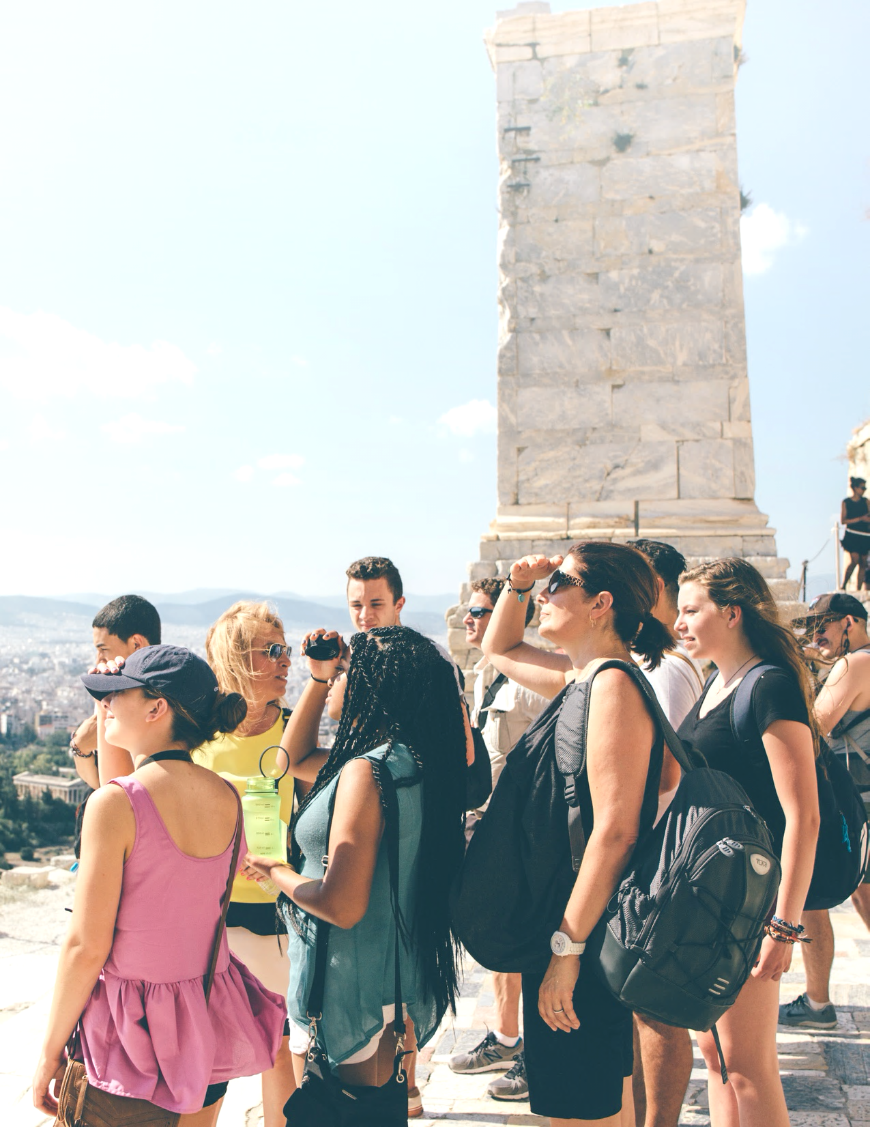
International Travel Program Proposal
Worcester Tech High School / Phil Cropper

  - Cuisine & Culture in Southern Italy - Spring 2023
  - eftours.com/CIS

Your partner in
travel-based learning

EF Education First is the world leader in international education. For over 55 years, we’ve partnered with educators around the world to help more than 15 million students gain new perspectives and build skills for the future through experiential learning.

Our mission is to empower educators to do their best work. At EF Educational Tours, we’re working to define the modern educational tour experience. Our itineraries are more than places to go and things to see. We build programs that challenge assumptions, spark connections, and inspire curiosity in young students. Students will expand their knowledge of the world around them, discover more about themselves, grow more confident and independent, and understand new people, places, and cultures.

We take care of every last detail of the tour experience—transportation and lodging, meal reservations and menus, museum tickets and local tour guides, and much more. That also includes behind-the-scenes elements, like safety checks at hotels and background checks on adult travelers. With all that taken care of, educators and students can focus on the bigger picture.

You’ll find all the details and more on the next few pages.

What’s contained in
this document

Pg. 2 Safety

Pg. 4 Liability protection

Pg. 6 Affordability

Pg. 7 Educational value

Pg. 8 Itinerary specifics

Pg. 8 Cost and payment options

Pg. 9 Sample hotels

Pg. 10 Sample meals

Pg. 11 Next steps

This proposal is property of EF Education First and the educator/school for which it was intended. Distributing, copying, and/or sharing it are prohibited. The proposal, including pricing, is valid for the educator, tour, and date(s) specifically mentioned herein. For additions, subtractions, or modifications, please contact your EF Tour Consultant.
© 2021 EF Education First. For full terms and Booking Conditions visit eftours.com/bc

Safety
v

Your students’ safety is our number one priority. We would never send a traveler to a location we believe to be unsafe—and with our extensive global presence, our best-in-the-industry experience, and our close working relationships with U.S. and international authorities, that’s a statement we can back up with real insight. Whether it’s a worldwide pandemic or a sprained ankle, a missed flight or confusing medical paperwork, we make sure every situation is taken care of.

*For specific information on EF’s response to COVID-19,
visit eftours.com/covid

Worldwide presence
EF’s global presence is truly unmatched. We have staff on the ground 365 days a year in over 50 countries. And we don’t just work in those countries—we call them home. EF team members live in nearly every one of our tour destinations, meaning we have the local knowledge to help keep our groups safe. That presence allows us to be there to support you on the ground wherever and whenever you need us.

24/7 emergency support
In the event that anything on tour goes wrong, EF staff is always available to help. Your Tour Director is your group’s constant companion and first point of contact in an emergency. Additionally, our fully trained support teams are on hand 24/7 to walk teachers through any issues and provide the resources necessary to get things back on track. Our Safety and Incident Response Team—comprised of industry experts, healthcare experts, and even former FBI personnel—is ready to spring into action 24 hours a day, 365 days a year. And when they aren’t directly helping EF travelers, they’re actively innovating on and shaping the new worldwide standards for cleanliness and safety.

Your team
This group is fully committed to your school’s trip and the safety of every traveler.

Operations Safety & Incident Response Team – This team is strategically based in our Boston, Panama, Tokyo, and Zurich offices to accommodate for all time zones. Available 24 hours a day, every day of the year, they are trained to react quickly if travelers need help. The team uses a combination of extensive training, simulations, incident response planning, and previous experience to manage emergencies. As needed, they can facilitate additional support for groups on tour, solve operational issues, arrange assistance from outside specialists, and liaise with local and international authorities.

Emergency Services & Support Team – Our support team is available 24/7 to help resolve any issue, from a missed flight to a lost passport to more serious on-tour incidents. They also facilitate communication between travelers and families in the event of an emergency at home. The team is made up of highly trained and dedicated EF staff in our Boston and Denver offices who are equipped to solve problems and answer questions that may come up, even outside of regular business hours.

Tour Director – Assigned exclusively to your tour for the length of the stay at your destination, your Tour Director meets your group at the airport and travels with you until your departure. All Tour Directors undergo a background check as permissible by local law every two years and are required to participate in ongoing EF safety trainings. They’re the first point of contact in an emergency and also communicate information to help travelers stay safe in a foreign destination. Tour Directors assist Group Leaders with hotel check-ins, coordinate meals, facilitate excursions with local guides, and much more. They’re also culturally connected and expertly trained to support impactful learning experiences.

Tour Consultant – This itinerary expert is devoted to the growth of your students. They are your school’s partner, working with you on everything from finding the perfect tour and enrolling students to offering fundraising advice and creating long-term travel programs for your school community. They work directly alongside the Group Leader (a.k.a. local teacher), right up until the moment of departure to make sure everything goes smoothly.

Traveler Support – Our team of support specialists are readily available to walk families through insurance inquiries, payment plans, food allergy issues, and any other topics that arise.

Chaperones – For every six travelers who enroll on your school’s tour, your group is eligible to bring along a chaperone for free (the first spot goes to the Group Leader). This allows for a 6:1 ratio of students to chaperones, who assist Group Leaders with supervision of students to help keep them safe.
Protection for travelers,
schools, and districts

We understand that unpredictable things can happen, either on tour or before departure. We offer a variety of protections, programs, and policies to make sure that, no matter what happens, travelers, schools, and districts are covered. We’re doing everything we can to make planning for the future as flexible as possible.

General liability insurance
All Group Leaders, schools, and districts who travel with EF are automatically added as additional insureds under our $50 million General Liability Policy, regardless of whether or not the tour is affiliated with the school. EF’s liability coverage is primary and non-contributory for covered third-party claims. The policy helps safeguard Group Leaders and their schools for covered third-party claims related to bodily injury or property damage, which includes providing a legal defense and covering legal costs for such claims. In addition, all travelers are required to sign EF’s Release and Agreement, which includes a release of liability of their Group Leader, school, and school board.

Flexibility to change tours
The world is always changing. And while our belief in the positive impact of travel is unwavering, it can feel hard to predict what life, here in the U.S. and abroad, will look like several months, a year, or even two years from now. When you decide to travel with EF, we want you to feel secure in that decision. That’s why these benefits are built into every EF program.

Peace of Mind
Provided to all groups
We understand that plans can change due to unforeseen circumstances. EF provides this exclusive program to account for such situations. It provides groups with flexibility to change the dates and destination of their tours in uncertain times. This program accounts for such circumstances and can be enacted up to 45 days prior to departure at the group level for any reason, including terrorism or other world events.

COVID Peace of Mind
Provided to groups departing before October 1, 2022
In addition to our standard Peace of Mind Program, EF provides an exclusive COVID-19 Peace of Mind Program to account for situations related to the COVID-19 pandemic. This program is automatically included for all travelers and can be enacted up to 45 days prior to departure at the group level, while specific options can be implemented at the individual level.

COVID Care Promise
Provided to all groups
If your child is diagnosed with COVID-19 while on tour, we will coordinate and facilitate support services and logistics including translation services, connections with local health care providers, communication with family, and flights home at no additional cost.

Protection for individual travelers
Travelers can help protect their investment and themselves from certain unexpected events and expenses while on tour with the Global Travel Protection Plan and Global Travel Protection Plan Plus.

Global Travel Protection Plan
Available to all travelers
Designed specifically with EF travelers in mind, this plan provides both pre-departure and post-departure benefits, including medical expense coverage that may apply on tour and tour cancellation for specified reasons.

Global Travel Protection Plan Plus
Available to all travelers
To further protect your investment from the unexpected, this plan provides all of the benefits included in the Global Travel Protection Plan as well as expanded cancellation protection.

Background checks for adult travelers
EF requires all adults (18 years and older) to pass a criminal background check before traveling on our student tours. This provides a safer tour experience for all travelers and aligns with the process and expectations of many school districts for adults who volunteer in schools or chaperone school activities. The secure process, provided by a leading professional provider, only identifies those individuals who could present a risk to student travelers while on tour.

Affordability

We believe every student should have the opportunity to travel. That’s why we’re dedicated to providing the lowest prices possible and giving travelers multiple resources for managing payments.

Tour Consultants work closely with teachers to build a tour that’s exactly right for your students. Through discussions with your teacher, they take into account learning objectives, cost, timing considerations, and any other factors to craft a tour that’s accessible to as many students as possible.

Resources for managing cost and payments

Automatic Payment Plan – Our recommended payment plan offers the ability to break the tour fee into smaller installments. With most tours planned well in advance, travelers can enroll for only $95, then pay over a long period of time—often up to 18 months or two years—with final payment due 30 days before departure. Families make payments directly to EF, with no payments going through the school.

Donation pages – Each student has access to their own unique and customizable donation page. The easy-to-share page makes it simple for friends and family to contribute a little something that is automatically applied to the balance of the tour, with no fees whatsoever.

Global Citizen Scholarship Fund – EF Educational Tours provides $100,000 worth of scholarships to students across the country every year. Any student is able to apply for the Global Citizen Scholarship, which is awarded on both a merit and need basis.

Risk-free enrollment period - New travelers who enroll by June 1, 2022 can cancel for any reason 30 days after enrollment for a full refund of 100% of the money paid to EF. To be eligible, the traveler must enroll on a tour with a scheduled departure date between October 1, 2022 and September 30, 2023.

Educational value

Our tours help prepare students for the future by teaching them more about the world, themselves, and the impact they can have on the world. Combining the power of experiential learning with the thrill of global travel, our tours help students:

- Expand their knowledge of the world around them
- Grow more confident and independent
- Understand new people, places, and cultures
- Discover more about themselves

To learn more about EF’s educational philosophy, visit https://www.eftours.com/our-story/educational-approach

EF is an accredited institution
We echo your commitment to education. Our travel-based learning approach is designed to blend classroom and experiential learning. This allows us to meet the same rigorous standards as schools like yours, ensuring students gain valuable experiences that transform the way they look at the world.

Earning credit for new experiences
EF makes it easy for students to turn their tour experience into high school credit, college credit, or to get a head start on their college essays—all while making their travel experience even more engaging.

- Students in grades 6 - 12 can earn .5 elective high school credit by successfully completing the final project as part of EF’s Personalized Learning Guide. Tuition is free.

- Students in grades 9 - 12 can earn 3.0 undergraduate credits, along with the
confidence that comes with taking a college course, by completing a series of
assignments and a final research project with our partner, Southern New Hampshire
University—all for just $215.

- Educators traveling on student tours may earn up to 45 free hours toward relicensure OR 3 or 6 graduate level credits ($285/$450) through Southern New Hampshire University.

Itinerary specifics

For more robust details, the complete itinerary is attached to this document. It includes specific locations, each day’s activities, travel plans, and more.

Price of the proposed tour
The tour program price covers a wide range of services that ensure students have an incredible experience. It includes all the planning and preparation that leads up to departure, travel and accommodations, plus logistical support and details once the group reaches their destination.

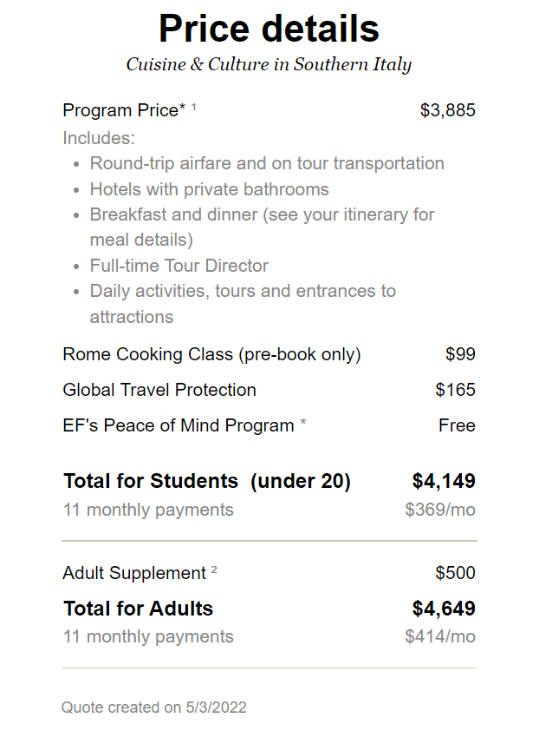

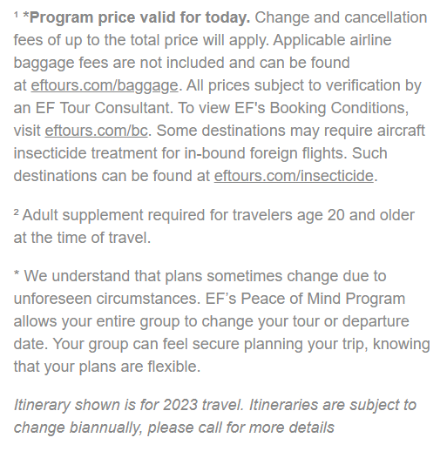

Sample hotels

Every hotel we work with must meet our high standards for safety, quality, and cleanliness. Hotels are vetted by our team to make sure they meet our requirements and are subsequently inspected regularly to ensure they continue to satisfy those parameters. Please note that hotels abroad may have different amenities than travelers are accustomed to in the United States.

Here are some examples of hotels students might stay in on tour:
Hotel Excel Ciampino | Rome
www.excelciampino.it
The Hotel Excel Ciampino is located approximately 12 miles southeast of Rome in the Castelli Romani region, once a favorite destination for popes and patrician families. The hotel, which consists of two adjacent buildings, features beautiful gardens for guests to enjoy. Each of the hotel’s 79 elegant rooms includes satellite television, telephone, hair dryer and free Wi-Fi access.

Grand Hotel Helio Cabala | Rome
www.heliocabala.it
Grand Hotel Helio Cabala is in Marino on the slopes of Mount Crescenzio overlooking Rome and the Lazio coast. Set at the start of the Castelli Romani, the hills around Rome, Helio Cabala is a 10-minute drive from Ciampino Airport and 4 kilometers from Lake Albano. Rome is easily reached by train. Rooms at Helio Cabala Grand Hotel come with satellite Tv and a fridge

Hotel Cardinal St Peter | Rome
https://www.cardinalhotelrome.com/
Hotel Cardinal St Peter is just a quick train ride away from the center of Rome and minutes from the Vatican Museums and St. Peter’s Basilica. For those looking to explore another side of Rome, the quiet district of Villa Pamphili will not disappoint. Equipped with modern facilities and a swimming pool, the hotel promises an enjoyable stay.

Sample meals

Meals are selected to establish a more immersive cultural experience and give students an idea of how locals eat. Below are some examples of what travelers can expect at the destination that your teacher has chosen, but please note that meals can vary from tour to tour.

Italy: Sample Meals
Tomato bruschetta, cannellini beans with garlic and sage, lasagna, gelato
Spaghetti with pesto, pork loin with spinach and potatoes, fruit salad

How I can help
with next steps

My name is Maggie Tragakis and I am Worcester Tech High School’s dedicated Tour Consultant. That means I’ll be working with Phil Cropper every step of the way to make sure everything is perfectly planned.

As we move forward in this process, here are some next steps to
keep in mind:

Make sure families take advantage of this Risk Free Enrollment Period and $100 Enrollment Discount ending June 1st

• Host a virtual information meeting on May 25th for parents and students regarding the Italy Trip

I hope this overview has given you the information you need to feel confident in EF as an educational travel provider. Should you have any questions or need any additional information, please don’t hesitate to reach out to me directly. EF is excited to partner with your school to bring this life-changing experiential learning opportunity to your students.

Sincerely,
Maggie Tragakis

“I am now more confident than ever in the safety and experiences of my students after working with EF on this trip. As a leader, I am committed to ensuring a global mindset throughout my district and student/teacher travel.”

Angela M., Administrator, Brunswick, ME

“I advocate for travel because the world is vast and diverse. If we want to truly understand our neighbors in other states or countries, we must reach out and meet them where they live. Travel provides a glimpse into another world that our students may have Googled or watched on a device, but living it with the smells, food, smiles, and various challenges teaches flexibility, tolerance, understanding, and empathy.”

- Chuck C., Group Leader, Central, SC

From a single tour to a whole program
A single tour can open up endless possibilities for a small group of students. Our goal at EF is to bring that experience to as many students as possible, including the broadest collection of students at your school. By progressing from a single tour to a consistent travel program, you’ll not only build a culture of exploration, but you’ll provide the opportunity of travel to even more students. We can work directly with you and your staff to establish a framework for your travel program that’s tailored specifically to your school’s needs and goals.

